**Estimates of excess deaths in Puerto Rico following Hurricane María**

Alexis R. Santos-Lozada, Pennsylvania State University

Jeffrey T. Howard, Independent Researcher

**Abstract**

**BACKGROUND**

This descriptive finding examines excess deaths following Hurricane María, in Puerto Rico for September and October 2017.

**OBJECTIVE**

We seek to determine the degree of excess deaths in Puerto Rico based on historical patterns of variability in deaths by month for the 2010-2016 period and using estimation techniques.

**METHODS**

Data for this study come from death records from the Puerto Rico Vital Statistics system. We aggregated data by month and year (2010-2016) and produced means (expected deaths) and 95% confidence intervals (C.I., or patterns of variability) for each month. Using public statements from the Puerto Rico Department of Public Safety, we estimate the number of deaths for September and October 2017 and compare it to the level of expected deaths considering the pattern of variability.

**RESULTS**

Expected deaths for September and October were 2,383 (95% C.I. 2,296-2,469) and 2,428 (95% C.I. 2,380 - 2,476), respectively. Estimates for total deaths, for September and October 2017 were 2,987 (95% CI 2,900-3,074) and 3,043 (95% C.I. 2995-3,091), respectively. The difference between our estimates and the upper 95% CI for the average deaths is 518 deaths for September and 567 deaths for October.

**CONCLUSIONS**

The mortality burden may higher than official counts, and may exceed the current official death toll by a factor of 10.

**CONTRIBUTION**

Presentation of deaths by year and month for Puerto Rico in the 2010-2016 period, derivation of excess deaths using estimation techniques, and comparison of estimates to historical patterns of deaths to assess the impact of Hurricane María.

1. **Introduction**

Hurricane Maria is the most devastating environmental disaster to have hit Puerto Rico in recent history, with winds of 155 mph it is the strongest since 1928 when the island was hit by Hurricane San Felipe with winds of 160 mph (Zorrilla, 2017). Recent discussions surrounding Hurricane Maria have centered on healthcare system resiliency (Alcorn, 2017), assessment of structural damages (Clery, 2017), but mostly on the number of deaths attributable to this environmental disaster (Sosa Pascual, 2017). This paper examines historical patterns of deaths by month for Puerto Rico, in the post-2010 period, and provides estimates of deaths for September and October 2017.

1. **Historical Patterns of deaths by year and month 2010-2016**

There is a wide body of literature that assesses mortality increases during and after natural disasters, but few are found within the demographic literature. These studies approach excess deaths by comparing historical point estimates, with estimates for the period of interest. The main examples come from public health and environmental sciences literature with the most studied being the 1995 Heat Wave in Chicago (Klinenberg, 2002; Semenza et al., 1996; Whitman et al., 1997), earthquakes in California (Kloner, Leor, Poole, & Perritt, 1997; Peek-Asa, Ramirez, Shoaf, Seligson, & Kraus, 2000) and most recently Hurricane Katrina (Brunkard, Namulanda, & Ratard, 2008; Jonkman, Maaskant, Boyd, & Levitan, 2009; Stephens et al., 2007). In this paper, we use data from the Puerto Rico Vital Statistics System (PRVSS) to present a new and timely approach to examine excess deaths in Puerto Rico for September and October 2017 – or following Hurricane Maria.

To address the question of how many deaths could be classified as excess in reference to historical patterns; we use death records from the PRVSS to establish averages and historical ranges by month using data for the post-2010 period (2010-2016). Figure 1 shows the historical trend for total deaths by year for Puerto Rico for the post 2010 period. During this period, total deaths in Puerto Rico ranged between 28,403 and 30,002 deaths per year.

**Figure 1: Total deaths by year in Puerto Rico, 2010-2016**

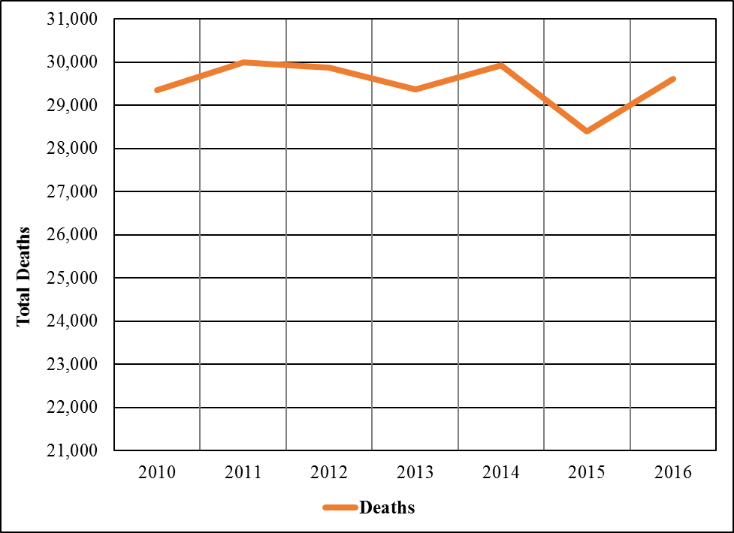

**Figure 2: Number of deaths by month and year, in Puerto Rico, 2010-2016**

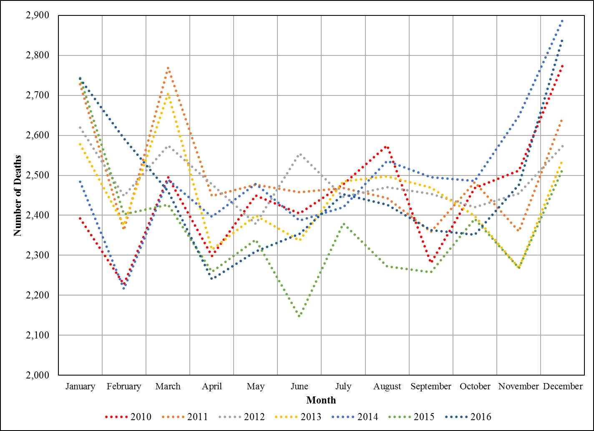



Figure 2, is a visual representation of total deaths by year and month for the 2010-2016 period. Table 1, includes the same information as Figure 1, but incorporates averages by month and corresponding 95% confidence intervals (95% C.I.). Total deaths by month within the period have been stable and clear patterns can be observed such as increased deaths in January and December. The data point for October 2014, was 2,891 deaths, a clear outlier to the pattern of variability. This data point exceeded the historical range by more than two standard deviations. We imputed the average number of deaths for this month in place of this outlier (2,486 deaths, still the highest number of the series), which provides a data point more consistent with the patterns observed for the 2010-2016 period. In addition, we include average and 95% C.I. for the total deaths by year, based on historical patterns the average number of deaths is 29,506 with corresponding ranges of variation of 29,097 and 29,914 deaths. This information was used to compute average deaths and corresponding 95% C.I. that are presented in Table 1 and Figure 3. The average number of deaths then represent the expected number of deaths and the 95% C.I. represents the ranges of deaths that would be considered within the historical range of variability.

**Figure 3: Average deaths and 95% confidence intervals by month in Puerto Rico, 2010-2016**

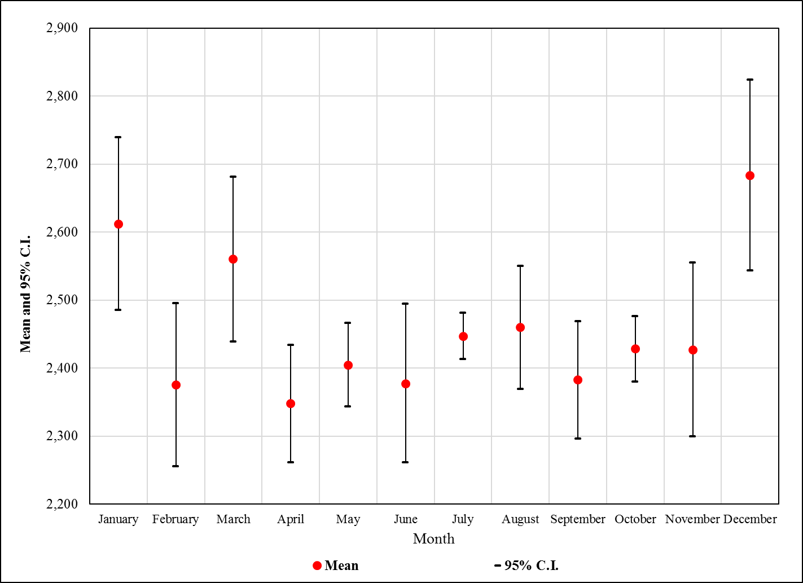

Based on these analyses the expected number of deaths for September is 2,383 (95% C.I. = 2,296-2,469) and for October is 2,476 (95% C.I. 2,380- 2,476).

While the Puerto Rico Department of Public Safety (PRDPS), and other government offices certify the number of deaths attributable to this natural disaster to be 55, other like the Mayor of San Juan have suggested that the actual number of deaths attributable to Hurricane María to be closer to 500. What do we know? Hector Pesquera, Secretary of Public Safety has released the following information:

*“The number of deaths for September 2017 is 2,838, with 95% of the deaths processed by the Puerto Rico Department of Health.”*

Using this information we estimate the number of deaths for September and October, based on the pattern observed in September as discussed by the PRDPS, and use historical levels of variability to establish 95% C.I.s for our estimates. After this, we determine the extent to which these estimates represent excess deaths above averages and corresponding levels of variation in Puerto Rico following Hurricane María.

Our estimate of total deaths for September 2017 (x), is produced using the following mathematical process:

(95/100) = (2,838/x) [1]

(95x) = 283,800 [2]

x = (283,800/95) [3]

x = 2,987 [4]

Based in the historical patterns of variability, the confidence interval for September is of ± 87 deaths, thus corresponding 95% C.I. is 2,900 - 3,074. To estimate the number of deaths for October 2017 we need to determine the ratio (R) that the estimate for September represents of the expected number of deaths for that month. This is done using the following mathematical process:

R = (2,987 deaths/2,383 deaths) [5]

R = 1.253462022660512 [6]

Using this ratio (R), we estimate the number of deaths for October (z), assuming the pattern observed in September continued in this month. This is achieved using the following mathematical process and the expected deaths for October (y):

z = R * y [7]

z = 1.253462022660512 * 2,428 deaths [8]

z ~ 3,043 deaths [9]

In order to account for the historical patterns of variability, we also establish confidence interval for October of ± 48 deaths, thus corresponding 95% C.I. is 2,995 – 3,091. The expected deaths for September and October, and estimate number of deaths, with corresponding 95% C.I.s are presented in Figure 4. We need to stress that the estimates for October are based on the patterns observed for September 2017.

The difference between our estimates and the upper 95% C.I. for the expected number of deaths is 518 deaths for September and 567 deaths for October. This represents a total of 1,085 excess deaths for the months of September and October alone.

**Figure 4: Expected deaths based on the 2010-2016 period and 2017 estimates for Puerto Rico**

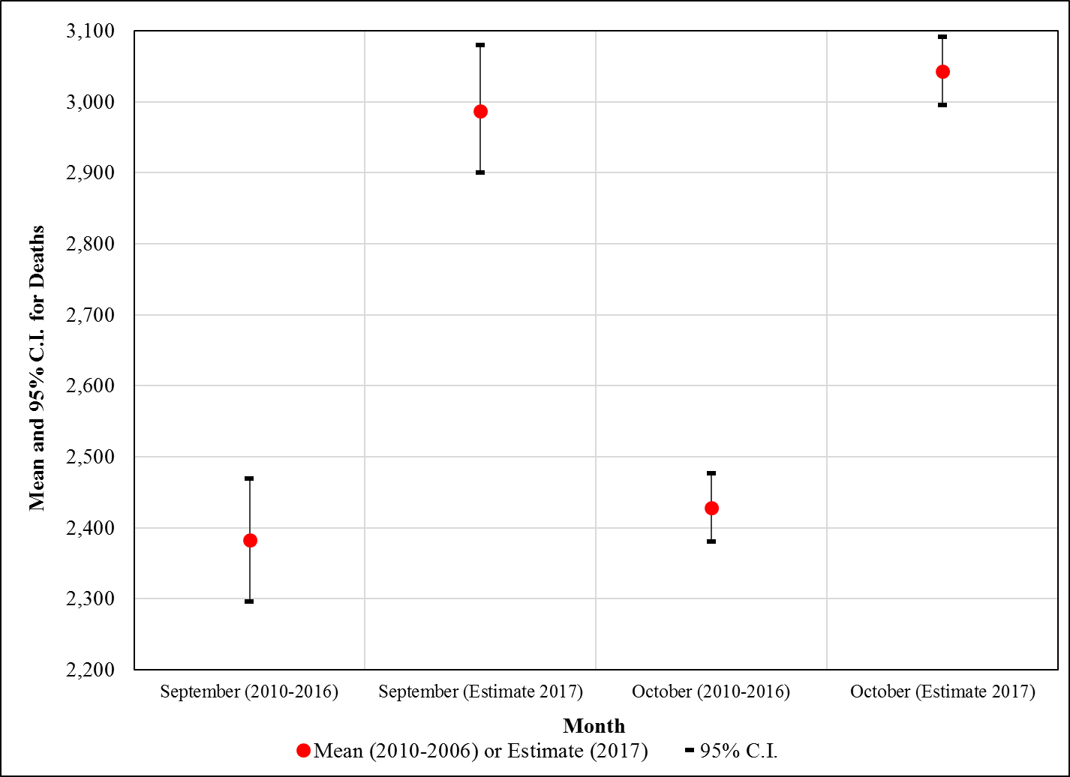

1. **Conclusion**

Our estimates suggest that the number of excess deaths in Puerto Rico may actually be closer to 500 for September and if the pattern held in October we estimate an additional 500 excess deaths. These estimates are higher than the official count which stands at 55 deaths in November, 2017. This would be also once all deaths are reported. Our findings suggest that the actual mortality burden attributable to Hurricane María may be far higher than current official statistics, and may exceed the current official death toll by a factor of 10, or more.

1. **Acknowledgments**

We acknowledge assistance provided by the Population Research Institute at Penn State University, which is supported by an infrastructure grant by the Eunice Kennedy Shriver National Institute of Child Health and Human Development (P2CHD041025). We also want to acknowledge the Puerto Rico Institute of Statistics and the Vital Statistics Division at the Puerto Rico Department of Health for providing access to the historical death records for the 2010-2016 period.

**References**

Alcorn, T. (2017). Puerto Rico’s health system after Hurricane Maria. *The Lancet*, *390*(10103), e24. https://doi.org/10.1016/S0140-6736(17)32591-6

Brunkard, J., Namulanda, G., & Ratard, R. (2008). Research: Hurricane Katrina deaths, Louisiana, 2005. *Disaster Medicine and Public Health Preparedness*, 1–9. https://doi.org/10.1097/DMP.0b013e31818aaf55

Clery, D. (2017). Hurricane damage threatens Arecibo’s future. *Science*, *357*(6358), 1336 LP-1337.

Jonkman, S. N., Maaskant, B., Boyd, E., & Levitan, M. L. (2009). Loss of life caused by the flooding of New Orleans after hurricane Katrina: Analysis of the relationship between flood characteristics and mortality. *Risk Analysis*, *29*(5), 676–698. https://doi.org/10.1111/j.1539-6924.2008.01190.x

Klinenberg, E. (2002). *Heat Wave: A Social Autopsy of the Disaster in Chicago*. University of Chicago Press.

Kloner, R. a, Leor, J., Poole, W. K., & Perritt, R. (1997). Population-based analysis of the effect of the Northridge Earthquake on cardiac death in Los Angeles County, California. *Journal of the American College of Cardiology*, *30*(5), 1174–1180. https://doi.org/10.1016/S0735-1097(97)00281-7

Peek-Asa, C., Ramirez, M. R., Shoaf, K., Seligson, H., & Kraus, J. F. (2000). GIS mapping of earthquake-related deaths and hospital admissions from the 1994 Northridge, California, earthquake. *Annals of Epidemiology*, *10*(1), 5–13. https://doi.org/10.1016/S1047-2797(99)00058-7

Semenza, J. C., Rubin, C. H., Falter, K. H., Selanikio, J. D., Flanders, W. D., Howe, H. L., & Wilhelm, J. L. (1996). Heat-Related Deaths during the July 1995 Heat Wave in Chicago. *New England Journal of Medicine*, *335*(2), 84–90. https://doi.org/10.1056/NEJM199607113350203

Sosa Pascual, O. (2017, November 8). María diaspara las muertes en Puerto Rico en un 43%. *Centro de Periodismo Investigativo*. Retrieved from http://periodismoinvestigativo.com/2017/11/maria-dispara-las-muertes-en-puerto-rico-en-un-43/

Stephens, K. U. S., Grew, D., Chin, K., Kadetz, P., Greenough, P. G., Burkle, F. M. J., … Franklin, E. R. (2007). Excess mortality in the aftermath of Hurricane Katrina: a preliminary report. *Disaster Medicine and Public Health Preparedness*, *1*(1), 15–20. https://doi.org/10.1097/DMP.0b013e3180691856

Whitman, S., Good, G., Donoghue, E. R., Benbow, N., Shou, W., & Mou, S. (1997). Mortality in Chicago attributed to the July 1995 heat wave. *American Journal of Public Health*, *87*(9), 1515–1518. https://doi.org/10.2105/AJPH.87.9.1515

Zorrilla, C. D. (2017). The view from Puerto Rico-Hurricane Maria and its aftermath. *The New England Journal of Medicine*, *363*(1), 1–3. https://doi.org/10.1056/NEJMp1002530